# C2- S1 HOUSE GAME

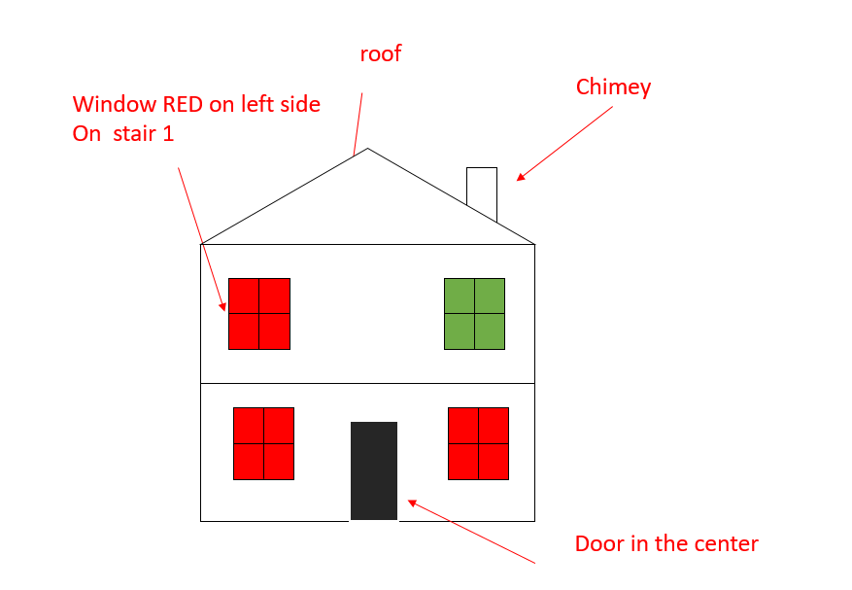

NOTATION

To make the code more readable, we omit the constructor, so this code:

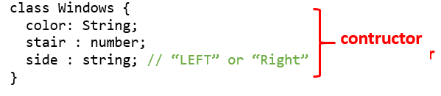

Is actually the following one *(including the constructor with color, stair, side as parameters)*

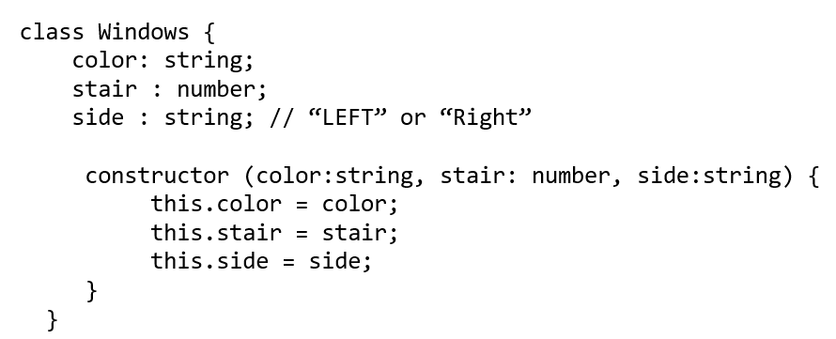

## EXERCICE 1

Draw on paper how the house(s) should look like, given this code

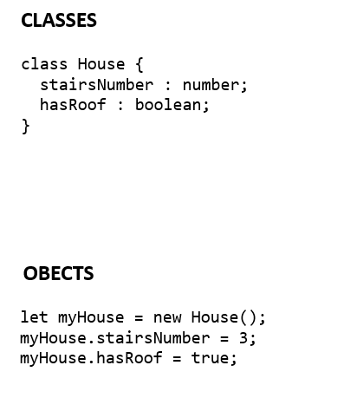

## EXERCICE 2

Draw on paper how the house(s) should look like, given this code

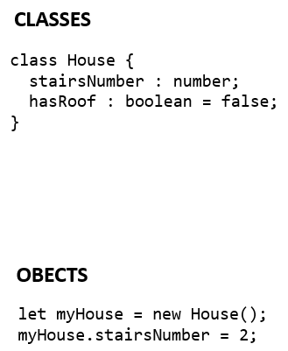

## EXERCICE 3

Draw on paper how the house(s) should look like, given this code

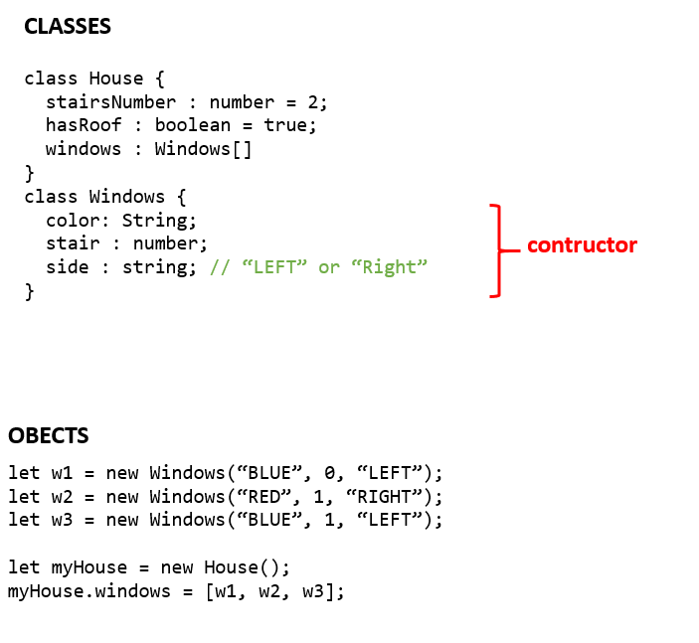

## EXERCICE 4

Write the code to instantiate object to create a house like the below draw

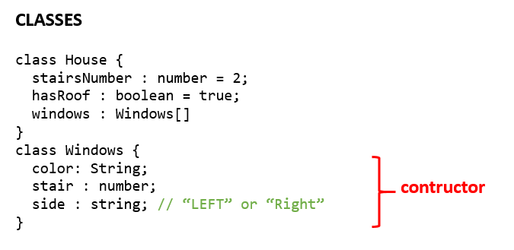

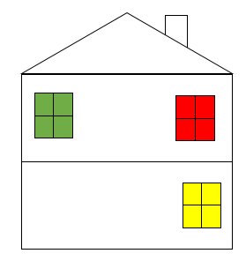

## EXERCICE 5

Draw on paper how the house(s) should look like, given this code

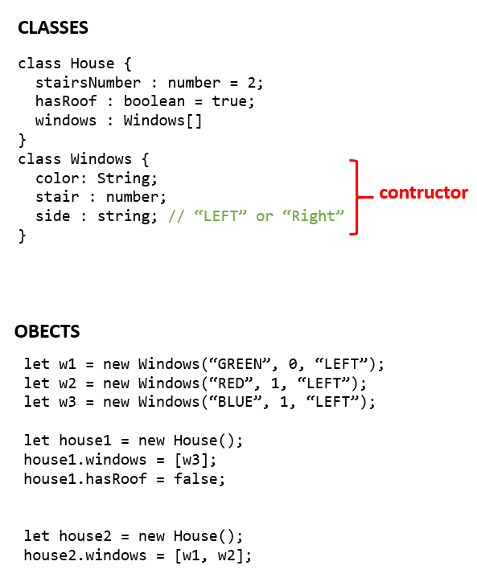

## EXERCICE 6

Now we define 3 kind of roofs, defined by their type (string)

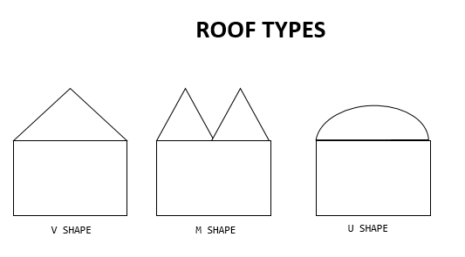

Draw on paper how the house(s) should look like, given this code

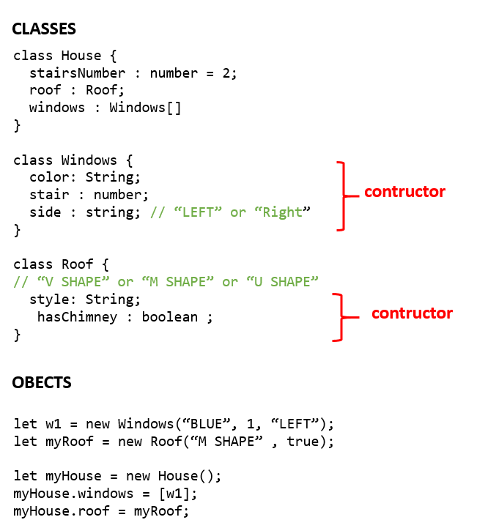

## EXERCICE 7

Draw on paper how the house(s) should look like, given this code

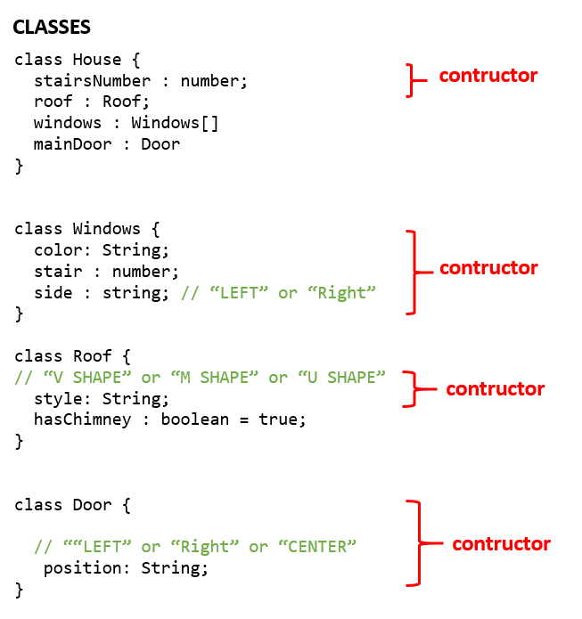

let w1 = new Windows(“BLUE”, 1, “LEFT”);

let w2 = new Windows(“BLUE”, 1, “RIGHT”);

let myHouse = new House();

let myRoof = new Roof("U SHAPE");

let myDoor = new Door("LEFT");

myHouse.roof = myRoof;

myHouse.windows = [w1, w2];

myHouse.door = myDoor;

## EXERCICE 8

Write the code to instantiate object to create a house like the below draw



